Human Detection Protocol

Contents

General 2

HD Application 2

Detection 2

Obstruction 4

HD HW 4

Protocol 5

HeartBeat 5

Protocol flow 6

Protocol Main Structure 7

Setup 7

MCU to HD Messages 8

**Setup** Message 8

Set Warning Message 9

Remove Warning Message 10

Remove All Warnings Message 10

Remove All Warnings Except Default Message 11

Set **Warning** to Default Message 11

Set Power Message 12

Get Warning Message 12

Get Warning Config Message 13

Get Setup Config Message 13

Get Status Message 14

HD to MCU Messages 15

Get Warning Response 15

Get Warning Config Response 16

Get Setup Config Response 17

Get Status Response 18

Acknowledge 19

Appendix A – CheckSum Byte 19

Check sum byte used to detect communication errors. 19

# General

## HD Application

The purpose of the HD application is to detect objects and notify the robot.

It also notifies the robot when its camera is being obstructed by an object and other vision metrics.

### Detection

#### General info

The HD application uses the OpenCV’s Deep Neural Network (DNN) module while using the SSD300 method in order to get a high performance in terms of time and confidence.

The current fps achieved on a Raspberri Pi-3 for detection is ~1.4fps.

When adding image capturing and other tasks the fps drops to ~1.24fps.

#### Warnings

The robot will define a set of warnings (max. 16) for the HD to detect.

Each warning holds: an ID, a single ROI (a polygon of 4 points) and other parameters such as confidence, Class object to detect, min out of max hits and min and max size of the object. (see Set Warning Message)

If the HD detects the requested object with its requested parameters, the bit representing this warning will be 1, otherwise 0.

**Note:**

* A warning can contain an overlapping polygon with any other warning.

#### Detection Algorithm

This is the basic algorithm calculated for each frame:

*foreach (detected_object):*

*{*

*foreach (warning):*

*if (detected_object.object_class == warning.object_class)* ***and***

*if (detected_object.confidence > warning.confidence)* ***and***

*if (detected_object.polygon* ***INTERSECTS*** *warning.polygon)* ***and***

*if (detected_object.w_h* ***<*** *warning.max_w_h )* ***and***

*if (detected_object.w_h* ***>*** *warning.min_w_h)* ***and***

*if (warning is hit min out of max times)*

*{*

*then* ***SEND WARNING***

*}*

*}*

**Notes:**

* **Note 1 –** There is no meaning for detecting multiple objects in a Warning - it is consider as a single detection (this is relevant for the counter of each polygon)
* **Notes 2 -** A detected object can appear in multiple warnings
* **Note 3** - Every n frames, the image will be **rotated by 90** degrees in order to detect a person lying down which is not detected normally.

#### Examples –

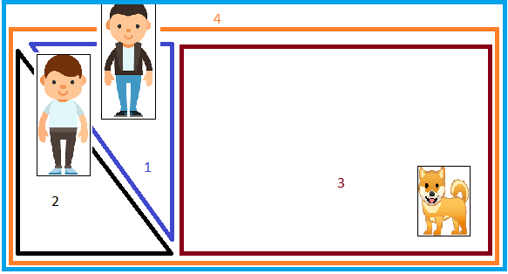

* The HD received 4 warnings (polygons) to detect and in each warning it needs to detect a person only (there are more parameters but they are ignored in this example)

Result:

* warning 1: ON
* warning 2: ON
* warning 3: OFF
* warning 4: ON

### Obstruction

#### General info

along detection the HD application will also analyze if any part of the camera is being blocked by an object over time (for m out of n times).

basic algo -

* + convert the image to gray
  + Divide the image into tiles - default (3x3)
    - Divide each tile into sub tiles - default (3x3)
      * In each tile - sample the intensity in the center -> intensity[b,g,r]
      * So now we have a list of intensity of all tiles
      * Calculate the variance of the list (1 gray channel) ⇒  var(∑gray)
  + IF any tile’s variance is below the threshold → consider this tile to be obstructed → The image is obstructed → Notify the Robot

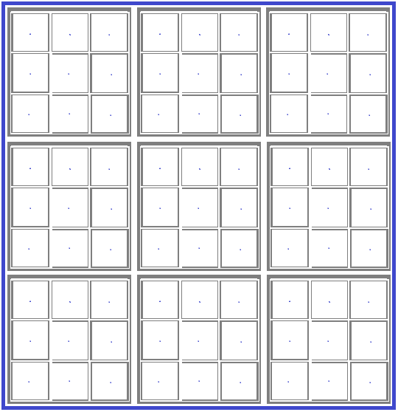

## HD HW

The protocol connects the new HD vision board to the robot CPU using I2C where the HD vision board is an I2C slave. The HD vision board doesn’t support I2C slave and therefore we are using STM0 CPU as UART to its I2C gateway. The same STM0 CPU will also control the power on/off according to a command from the robot CPU.

# Protocol

Since the communication is synchronous, the **robot which is the master** is always the initiator of the messages while The HD vision will always respond with Ack/Nack or with a GetWarningResponse message (see protocol flow below)

There are 2 types of messages:

* messages that writes information to the slave
* messages that requests to read information from the slave

## HeartBeat

The GetWarningMessage with its response GetWarningResponse are used as the heartbeat of the system.

The GetWarningResponse holds information and status of the HD.

## Protocol flow

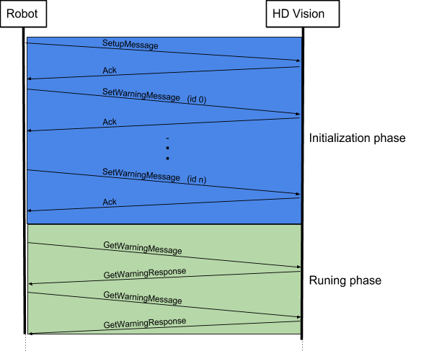

## Protocol Main Structure

|  |  |  |  |  |
| --- | --- | --- | --- | --- |
| **Preamble** | **Length** | **Opcode** | **Data** | **Checksum** |
| 8 bit | 8 bit | 8 bit | n bytes | 8 bit |

**Preamble** - Can be used for fragmentation. currently there is no need for it. therefor it is constant = ***0xAA***.

**Length -** Holds the length of the data + 4 bytes (Preamble, Length, Opcode and checksum)

**Data** - holds the data of the message as detailed

**Opcode** - Describes the opcode of the message. There are 4 types of messages:

**Checksum** – Calculation should be with the length of the whole message including 4 bytes (Preamble, Length, Opcode and checksum).

## Setup

RS232 Details:

###### Baud Rate: ?

###### Byte Size:

Parity:

Stop Bits:

# MCU to HD Messages

## Setup Message

Set the HD **general** parameters.

This message should be acknowledged upon reception with ‘Acknowledge’ message.

|  |  |  |
| --- | --- | --- |
| **Byte #** | **Description** | **Content** |
| 1 | Preamble | 0xAA |
| 2 | Message Length | total number of bytes in the message including the 4 bytes (Preamble, Length, Opcode and checksum) |
| 3 | Message Opcode | 0xB1 |
| 4 | rotate_image_cycle | Every N cycles rotate the image by 90 deg. and use it for the detection. This is done in order to detect a person laying down which is not detected normally.  e.g. – if rotate_image_cycle=10 🡺 every 10 frames the detection will be done on an image rotated by 90 degrees. |
| 5-6 | obstruction_threshold | Threshold of Variance of the intensity. e.g. 1000  Thresholds to evaluate when the camera or part of it is being blocked\obstructed by an object. |
| 7 | no_visibility_threshold | Threshold of the intensity. e.g. 63. [0-255]  Thresholds to define the quality of the image |
| 8 | medium_visibility_threshold | Threshold of the intensity. e.g. 128. [0-255]  Thresholds to define the quality of the image |
| 9 | full_visibility_threshold | Threshold of the intensity. e.g. 190. [0-255]  Thresholds to define the quality of the image |
| 10 | minimun_obstruction_hits | Repeatability value thresholds to define obstruction of camera. if any tile is being blocked for min out of max times → then a part of the camera is considered to be blocked. |
| 11 | maximum_obstruction_hits | Repeatability value thresholds to define obstruction of camera. if any tile is being blocked for min out of max times → then a part of the camera is considered to be blocked. |
| 12 | Logging Debug | Sets the logging level. **Used for debugging**  0 – False (Info level)  1 – True (debug level) |
| 13 | Show Images | Displays the images on a remote console using the X11 Server. **Used for debugging**. The polygons warnings and the detected boxes are drawn on these images.  **Note: This slows down the performance of the HD** **significantly!**  0 – False  1 – True |
| 14 | Save Images | Saves the images on the disk. **Used for debugging**. The HD uses 500MB (~1850 images) for saving images and doesn’t exceed this size. When approaching the size limit old images will be deleted.  **Note: This slows down the performance of the HD!**  0 – False  1 – True |
| 15 | Check Sum | See appendix A |

## Set Warning Message

Command the HD to create a new Warning Message.

This message should be acknowledged upon reception with ‘Acknowledge’ message.

|  |  |  |
| --- | --- | --- |
| **Byte #** | **Description** | **Content** |
| 1 | Preamble | 0xAA |
| 2 | Message Length | total number of bytes in the message including the 4 bytes (Preamble, Length, Opcode and checksum) |
| 3 | Message Opcode | 0xB2 |
| 4 | warning_id | Values – 0 to 15 |
| 5-20 | Polygon | Each polygon is an array of 4 Points.  Each Point is 4 bytes: x=2 bytes , y=2 bytes. |
| 21 | object_class | Bit 0 : person  Bit 1 : animal (cat or dog)  Bit 2 : Furniture (sofa, diningtable, chair, tvmonitor)  Bit 3 : toys (aeroplane, boat, cow, train)  Bit 4 : Vehicle (bicycle, motorbike, car,bus)  Bit 5 : reserved  Bit 6 : reserved  Bit 7 : reserved  e.g. - if we set object_class to 3, then we should encounter in that warning only ‘person’ and ‘animal’ |
| 22-23 | object_min_w_h | Min width and height of an object to detect |
| 24-25 | object_max_w_h | Max width and height of an object to detect |
| 26 | minimum_confidence | Value: 0-100.  Value unit = %  Each detection has a confidence value which represents the  HD will ignore detections below this value |
| 27 | minimun_detection_hits | min out of max hits will be considered as “Warning on” |
| 28 | maximun_detection_hits | min out of max hits will be considered as “Warning on” |
| 29 | is_default | This property is relevant to Set Warnings to Default Message and to Remove All Warnings Except Default Message  If True, this warning will not be removed when this message is invoked. Note: this property is ignored when Remove All Warnings Message is invoked  0 – False  1 - True |
| 30 | Check Sum | See appendix A |

## Remove Warning Message

Command the HD to remove a warning by its id.

This message should be acknowledged upon reception with ‘Acknowledge’ message.

|  |  |  |
| --- | --- | --- |
| **Byte #** | **Description** | **Content** |
| 1 | Preamble | 0xAA |
| 2 | Message Length | total number of bytes in the message including the 4 bytes (Preamble, Length, Opcode and checksum) |
| 3 | Message Opcode | 0xB3 |
| 4 | warning_id | Values – 0 to 15 |
| 5 | Check Sum | See appendix A |

## Remove All Warnings Message

Command the HD to remove all warnings. This message contains no data

This message should be acknowledged upon reception with ‘Acknowledge’ message.

|  |  |  |
| --- | --- | --- |
| **Byte #** | **Description** | **Content** |
| 1 | Preamble | 0xAA |
| 2 | Message Length | total number of bytes in the message including the 4 bytes (Preamble, Length, Opcode and checksum) |
| 3 | Message Opcode | 0xB4 |
| 4 | Check Sum | See appendix A |

## Remove All Warnings Except Default Message

Command the HD to **remove all warnings** except the default warnings. This message contains no data

This message should be acknowledged upon reception with ‘Acknowledge’ message.

|  |  |  |
| --- | --- | --- |
| **Byte #** | **Description** | **Content** |
| 1 | Preamble | 0xAA |
| 2 | Message Length | total number of bytes in the message including the 4 bytes (Preamble, Length, Opcode and checksum) |
| 3 | Message Opcode | 0xB5 |
| 4 | Check Sum | See appendix A |

## Set **Warning** to Default Message

Command the HD to set a specific warning or all warnings to be default.

A Warning with property is_default = True will not be removed when Remove All Warnings Except Default Message is invoked.

This message should be acknowledged upon reception with ‘Acknowledge’ message.

|  |  |  |
| --- | --- | --- |
| **Byte #** | **Description** | **Content** |
| 1 | Preamble | 0xAA |
| 2 | Message Length | total number of bytes in the message including the 4 bytes (Preamble, Length, Opcode and checksum) |
| 3 | Message Opcode | 0xB6 |
| 4 | warning_id | Values – 0 to 15 |
| 5 | all_warnings | 0 – False  1 – True  If True – warning_id will be ignored |
| 5 | Check Sum | See appendix A |

## Set Power Message

Command the HD to power on/off.

This message should be acknowledged upon reception with ‘Acknowledge’ message.

|  |  |  |
| --- | --- | --- |
| **Byte #** | **Description** | **Content** |
| 1 | Preamble | 0xAA |
| 2 | Message Length | total number of bytes in the message including the 4 bytes (Preamble, Length, Opcode and checksum) |
| 3 | Message Opcode | 0xB7 |
| 4 | power_cmd | 0 – power off  1 – power on |
| 5 | Check Sum | See appendix A |

## Get Warning Message

Command the HD to reply with the Get Warning Response message.

This message should be acknowledged upon reception with Get Warning Response message.

|  |  |  |
| --- | --- | --- |
| **Byte #** | **Description** | **Content** |
| 1 | Preamble | 0xAA |
| 2 | Message Length | total number of bytes in the message including the 4 bytes (Preamble, Length, Opcode and checksum) |
| 3 | Message Opcode | 0xB8 |
| 4 | Check Sum | See appendix A |

## Get Warning Config Message

Command the HD to reply with the Get Warning Config Response message.

This message should be acknowledged upon reception with Get Warning Config Response message.

|  |  |  |
| --- | --- | --- |
| **Byte #** | **Description** | **Content** |
| 1 | Preamble | 0xAA |
| 2 | Message Length | total number of bytes in the message including the 4 bytes (Preamble, Length, Opcode and checksum) |
| 3 | Message Opcode | 0xB9 |
| 4 | warning_id | Values – 0 to 15 |
| 5 | Check Sum | See appendix A |

## Get Setup Config Message

Command the HD to reply with the Get Setup Config Response message.

This message should be acknowledged upon reception with Get Setup Config Response message.

|  |  |  |
| --- | --- | --- |
| **Byte #** | **Description** | **Content** |
| 1 | Preamble | 0xAA |
| 2 | Message Length | total number of bytes in the message including the 4 bytes (Preamble, Length, Opcode and checksum) |
| 3 | Message Opcode | 0xBA |
| 4 | Check Sum | See appendix A |

## Get Status Message

Command the HD to reply with the Get Status Response message.

This message should be acknowledged upon reception with the Get Status Response message.

|  |  |  |
| --- | --- | --- |
| **Byte #** | **Description** | **Content** |
| 1 | Preamble | 0xAA |
| 2 | Message Length | total number of bytes in the message including the 4 bytes (Preamble, Length, Opcode and checksum) |
| 3 | Message Opcode | 0xBB |
| 4 | Check Sum | See appendix A |

# HD to MCU Messages

## Get Warning Response

Status message of the HD. Also used as the “heartbeat” of the system.

Messages from HD to MCU can’t be acknowledged.

|  |  |  |
| --- | --- | --- |
| **Byte #** | **Description** | **Content** |
| 1 | Preamble | 0xAA |
| 2 | Message Length | total number of bytes in the message including the 4 bytes (Preamble, Length, Opcode and checksum) |
| 3 | Message Opcode | 0xC1 |
| 4-6 | warning0 :1;  warning1 :1;  warning2 :1;  warning3 :1;  warning4 :1;  warning5 :1;  warning6 :1;  warning7 :1;  warning8 :1;  warning9 :1;  warning10 :1;  warning11 :1  warning12 :1;  warning13 :1;  warning14 :1;  warning15 :1;  visibility_light_level :2;  visibility_obstruction :1;  spare :5 | **Warningxx:**  0 – no warning  1 – warning on  **visibility_light_level:**  0 - no visibility - under “no_visibility_threshold”  1 - between “no_visibility_threshold” and “medium_visibility_threshold”  2 - between “medium_visibility_threshold” and “full_visibility_threshold”  3 - full visibility - above “full_visibility_threshold”  **visibility_obstruction:**  0 - no obstruction  1 - is obstructed |
| 7 | Check Sum | See appendix A |

## Get Warning Config Response

Returns the details of a warning. Used for verifying that the HD holds the correct parameters

Messages from HD to MCU can’t be acknowledged.

|  |  |  |
| --- | --- | --- |
| **Byte #** | **Description** | **Content** |
| 1 | Preamble | 0xAA |
| 2 | Message Length | total number of bytes in the message including the 4 bytes (Preamble, Length, Opcode and checksum) |
| 3 | Message Opcode | 0xC2 |
| 4 | warning_id | Values – 0 to 15 |
| 5-20 | Polygon | Each polygon is an array of 4 Points.  Each Point is 4 bytes:  x=2 bytes , y=2 bytes 🡺 values from 0-300 |
| 21 | object_class | Bit 0 : person  Bit 1 : animal (cat or dog)  Bit 2 : Furniture (sofa, diningtable, chair, tvmonitor)  Bit 3 : toys (aeroplane, boat, cow, train)  Bit 4 : Vehicle (bicycle, motorbike, car,bus)  Bit 5 : reserved  Bit 6 : reserved  Bit 7 : reserved  e.g. - if we set object_class to 3, then we should encounter in that warning only ‘person’ and ‘animal’ |
| 22-23 | object_min_w_h | Min width and height of an object to detect |
| 24-25 | object_max_w_h | Max width and height of an object to detect |
| 26 | minimum_confidence | Value: 0-100.  Value unit = %  Each detection has a confidence value  HD will ignore detections below this value |
| 27 | minimun_detection_hits | min out of max hits will be considered as “Warning on” |
| 28 | maximun_detection_hits | min out of max hits will be considered as “Warning on” |
| 29 | is_default | This property is relevant to Set Warnings to Default Message  If True, this warning will not be removed when this message is invoked. Note: this property is ignored when Remove All Warnings Message is invoked  0 – False  1 – True |
| 30 | Check Sum | See appendix A |

## Get Setup Config Response

Returns the HD **general** parameters. Used for verifying that the HD holds the correct parameters

Messages from HD to MCU can’t be acknowledged.

|  |  |  |
| --- | --- | --- |
| **Byte #** | **Description** | **Content** |
| 1 | Preamble | 0xAA |
| 2 | Message Length | total number of bytes in the message including the 4 bytes (Preamble, Length, Opcode and checksum) |
| 3 | Message Opcode | 0xC3 |
| 4 | rotate_image_cycle | Every N cycles rotate the image by 90 deg. and use it for the detection. This is done in order to detect a person laying down which is not detected normally.  e.g. – if rotate_image_cycle=10 🡺 every 10 frames the detection will be done on an image rotated by 90 degrees. |
| 5-6 | obstruction_threshold | Threshold of Variance of the intensity. e.g. 1000  Thresholds to evaluate when the camera or part of it is being blocked\obstructed by an object. |
| 7 | no_visibility_threshold | Threshold of the intensity. e.g. 63 - [0-255]  Thresholds to define the quality of the image |
| 8 | medium_visibility_threshold | Threshold of the intensity. e.g. 128 - [0-255]  Thresholds to define the quality of the image |
| 9 | full_visibility_threshold | Threshold of the intensity. e.g. 190 - [0-255]  Thresholds to define the quality of the image |
| 10 | minimun_obstruction_hits | Repeatability value thresholds to define obstruction of camera. if any tile is being blocked for min out of max times → then a part of the camera is considered to be blocked. |
| 11 | maximum_obstruction_hits | Repeatability value thresholds to define obstruction of camera. if any tile is being blocked for min out of max times → then a part of the camera is considered to be blocked. |
| 12 | Logging Debug | Sets the logging level. **Used for debugging**  0 – False (Info level)  1 – True (debug level) |
| 13 | Show Images | Displays the images on a remote console using the X11 Server. **Used for debugging**. The polygons warnings and the detected boxes are drawn on these images.  **Note: This slows down the performance of the HD** **significantly!**  0 – False  1 – True |
| 14 | Save Images | Saves the images on the disk. **Used for debugging**. The HD uses 500MB (~1850 images) for saving images and doesn’t exceed this size. When approaching the size limit old images will be deleted.  **Note: This slows down the performance of the HD!**  0 – False  1 – True |
| 15 | Check Sum | See appendix A |

## Get Status Response

Returns the **versions** of the HD.

Messages from HD to MCU can’t be acknowledged.

|  |  |  |
| --- | --- | --- |
| **Byte #** | **Description** | **Content** |
| 1 | Preamble | 0xAA |
| 2 | Message Length | total number of bytes in the message including the 4 bytes (Preamble, Length, Opcode and checksum) |
| 3 | Message Opcode | 0xC4 |
| 4-5 | sw_version | {x.x} 🡺 {byte #4.byte #5} |
| 6-7 | hw_version | {x.x} 🡺 {byte #6.byte #7} |
| 8 | Check Sum | See appendix A |

## Acknowledge

This message is sent when the Wire system needs to acknowledge the MCU that a certain message was received.

|  |  |  |
| --- | --- | --- |
| **Byte #** | **Description** | **Content** |
| 1 | Preamble | 0xAA |
| 2 | Message Length | total number of bytes in the message including the 4 bytes (Preamble, Length, Opcode and checksum) |
| 3 | Message Opcode | 0xD1 – Ack  0xD2 - Nack |
| 4 | Check Sum | See appendix A |

# Appendix A – CheckSum Byte

### Check sum byte used to detect communication errors.

Use the following c language code (if needed) to calculate the check sum byte:

packet – pointer to the packet

length – number of bytes in the packet without the check sum byte

Important: don’t forget the NOT operation on the returned sum at the end of the function

**byte Check_sum(byte* packet, short length)**

**{**

**short i=0;**

**long sum=0;**

**for (i=0;i<length;i++)**

**sum += packet[i];**

**return((byte)(~sum));**

**}**

**Document Version History**

|  |  |  |
| --- | --- | --- |
| **Version** | **Date** | **Author** |
|  |  |  |